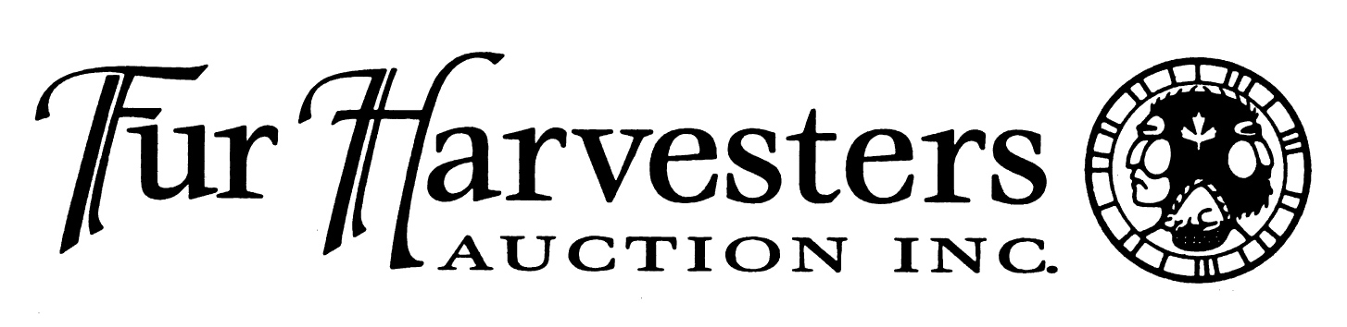

FHA's Annual Trappers Convention

April 10th & 11th, 2015
The theme for this year's convention is:
Trapping gadgets, gizmos & inventions.
Admission
$7.00 per person - Kids under the age of 16 are free
(Admission covers both days and Friday night's entertainment)
Location
Fur Harvesters Auction
1867 Bond Street (Off Gormanville Rd.)
North Bay, ON P1B 8K6
Bring the whole family, and find out what Canada's oldest land based industry is all about!
For more information visit: www.furharvesters.com

